Literacy Sponsors Needed
For Burlington Housing Authority’s Reach for the Stars Reading Incentive Program
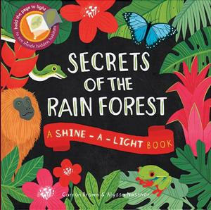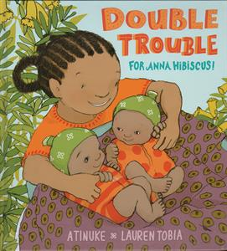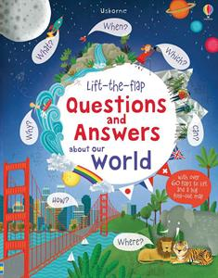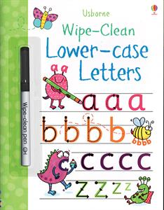
Our goal:
A literacy sponsor for EVERY child at Burlington Housing Authority’s summer program!
What is a Literacy Sponsor?
A Literacy Sponsor donates $25 to sponsor a child’s reading throughout the summer. The child, parents and teachers make a commitment for every child to read or be read to at least 20 minutes per day. Your sponsored child(ren) will receive at least $25 worth of new books upon completing the reading program!
WHY? Research shows that “The most successful way to improve the reading achievement of low-income children is to increase their access to print.” That means quality books in their hands and their homes!
Usborne Books & More will match every monetary donation at 50% which will allow each child in the BHA summer program to have books of their own AND to establish a library at BHA!
100% of your tax deductible donation to Burlington Housing Authority will be used to change the lives of children through literacy!
Questions: Contact Amy Segposyan, Usborne Consultant, asegposyan@gmail.com, 845-544-4256 or Veronica Revels, Executive Director, Burlington Housing Authority, bha@burlingtonha.org, 336-226-8421, ext. 203
I would like to sponsor:
- Corporate sponsor Name _____________________________________________
- 10 children - $250 Address _____________________________________________
- 4 children - $100 Corporation/organization ______________________________
- 2 children - $50 ______________________________________________
- 1 child - $25 Phone/email __________________________________________
Send this form with checks payable to Burlington Development Corp. 443 Parkview Drive, Burlington, NC 27215, attn.: A. Segposyan or an on-line donation at https://www.youcaring.com/burlington-housing-authority-553825

